

# 2025 Tender Hearts 5K Walk/Run

Join us for the 2025 Tender Hearts 5K Walk/Run, hosted by Tender Hearts. This event will take place on Sunday, October 12th at Glasgow Park in Newark, Delaware. The walk/run will begin at 10:00 am.

By participating in this event, you have the opportunity to make a meaningful difference in the lives of medically fragile children. We are a 501(c) non-profit organization dedicated to supporting these children and improving their quality of life.

The funds raised from this event, as well as others, are specifically used to enhance the mobility of medically fragile children. We provide essential items such as stair rail lifts, mobility bikes, wheelchairs, walkers, and home improvements like ramps and bathroom provisions. These resources enable children to interact actively with others and enjoy a greater level of mobility.

Additionally, your contributions help cover the costs of necessary prescriptions, life-saving medical equipment, clothing, educational items, care packages, and toys for the children during the holidays. We work closely with esteemed organizations like Nemours Children's Hospital, Highmark of Delaware, Unity Way, Easter Seals, and many others.

Tender Hearts strives to provide a better quality of life for these children and their families. With the generous support of sponsors and donors like yourself, we can bring smiles to these kids' faces. Last year alone, we assisted over 270 children through our programs.

Your support is vital in our mission to help medically fragile children in Delaware. Attached is information that will give you a better understanding of our organization and how you can contribute throughout the year. We also encourage you to consider sponsoring and making monetary donations for the 2025 Tender Hearts 5K Walk/Run. Your generosity is greatly appreciated.

For more information about Tender Hearts, please visit our website at [www.tenderheartsde.org](http://www.tenderheartsde.org/). You can also stay connected with us on Facebook by liking our page at [https://www.facebook.com/tenderheartsde/.](https://www.facebook.com/tenderheartsde/) We regularly update our page with information about our events and community initiatives.

Join us in making the 2025 Tender Hearts 5K Walk/Run a resounding success! Together, we can bring joy to the lives of these children and their families.

Sincerely,

Debria G. Doherty Chairperson

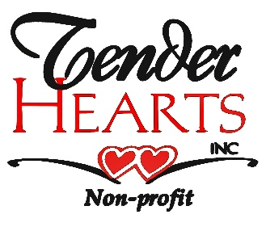

THE ORGANIZATION OUR PROGRAMS

**Adopt A Family**

We offer assistance with families who have a medically fragile child, or children. We provide Christmas Gifts and or special mobility gifts.

**Beads of Courage**

Beads of courage are bracelets given to a child to distract them from the pain and help them count down to the end of uncomfortable medical

procedures and treatments.

**Mobility Programs**

We offer assistance with mobility items such as running limbs, wheelchairs, specialized crutches, and much more.

**ELSA (Early Learning Success in Academics)**

The ELSA Program provides parents of preschool age children who have not yet entered kindergarten the academic materials needed to help foster learning during their oncology treatments. Children are given a colorful backpack filled with books on coloring, shapes, numbers and alphabet as well as, crayons and pencils.

**Milestones**

Assist families with medically fragile children to help put a smile on that child’s face and improve their quality of life. This service offers parents the opportunity to celebrate milestones in that child’s life such as a Birthday, a medical milestone, and the Holidays.

Tender Hearts, Inc. is a local non-profit founded in 2014 to assist and support medically fragile children and their families through various programs, partnerships and fundraisers. We offer individual family/child support to aid them in having a better quality of life.

Families providing care for a medically fragile child with complex health conditions are often overwhelmed emotionally and financially.

Frequent hospitalizations, coordination of care, stress on the family unit, maintaining employment, and mounting medical bills create multiple challenges. With all of the struggles, many times the child's spirit is forgotten and the lack of fun of just being a child. Tender Hearts is here to help put a smile on their faces in so many ways.

We partner with Nemours Hospital, Ronald McDonald House and many other facilities to enable us to reach more children as well as individual children and families.

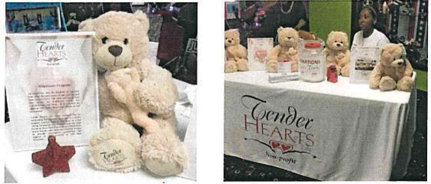

## OUR MISSION

*“Supporting medically fragile children in order to create a better quality of life”*

# SPONSORSHIP PACKET DETAIL

|  |  |  |  |  |
| --- | --- | --- | --- | --- |
|  | **Platinum**  **$5,000** | **Gold**  **$3,000** | **Silver**  **$1,000** | **Bronze**  **$500.00** |
| Race Registration | up to 5 | up to 3 |  |  |
| Logo on Runner T-Shirts |  | ✓ | ✓ |  |
| Ability to Speak To Audience | ✓ |  |  |  |
| Company Logo and Link on Tender Hearts Website | ✓ | ✓ | ✓ | ✓ |
| Social Media Recognition | ✓ | ✓ | ✓ | ✓ |
| Company Logo and Website Link on Runner Confirmation Emails | ✓ | ✓ | ✓ | ✓ |
| Logo on Sleeve on T-Shirts | ✓ |  |  |  |

**SPONSOR AGREEMENT**

COMPANY:

CONTACT PERSON:

ADDRESS:

CITY: STATE: ZIP

PHONE: ( ) FAX:_( )

## SPONSOR LEVEL:

☐ Platinum ($5,000) ☐ Gold ($3,000) ☐ Silver ($1,000) ☐ Bronze ($500)

**METHOD OF PAYMENT**: (All sponsorships/donations are payable to: Tender Hearts, Inc.)

* Payment Enclosed
* Send Invoice
* Credit Card
* Check

Card type: ☐ Visa ☐ Mastercard ☐ American Express

Name on Card (please print):

Card Number: Expiration Date: / CVV:

Signature: Date:

## Please send completed forms to one of the following:

Fax: 302-239-3600

Mail: P..O. Box 56, 651 Valley Rd, Hockessin, DE 19707-0056E-Mail: [donations@tenderheartsde.org](mailto:donations@tenderheartsde.org)

If you would prefer to phone in your donation or sponsor fee: 302-598-1654/302-234-1017

PLEASE PROVIDE ALL SPONSORSHIP DONATIONS NO LATER THAN October 1st, 2025 TO BE INCLUDED ON T-SHIRT.

We appreciate your support in making a difference in children’s lives! (Please make a copy of this form for your records)